**Safety in civil Construction**

M.D. THOUFEQUE

DCE I year II SEM

DEPARTMENT OF CIVIL ENGINEERING

SREE VISVESVARAYA INSTITUTE OF TECHNOLOGY AND SCIENCE

UDAY KUMAR GOUD

DCE I year II SEM

DEPARTMENT OF CIVIL ENGINEERING

SREE VISVESVARAYA INSTITUTE OF TECHNOLOGY AND SCIENCE

**Abstract**

The statistic of accidents at construction sites give us a picture that Malaysian construction industry is one of the critical sectors that need a huge and fast overhaul from the current site safety practices. Accident don’t just happen, they are caused by unsafe acts, unsafe conditions or both. Most accidents result from a combination of contributing causes and one or more unsafe acts and unsafe condition. In order to improve the overall safety performance we need to investigate the root causes of construction accidents. That knowledge could be utilised in formulating more conducive working conditions and environments at construction sites. Therefore, a study has been conducted to identify the causes of accident at construction sites. This study was started out by reviewing literature from journals, books and web pages. Then reported accidents cases kept by the Department of Occupational Safety and Health Malaysia (DOSH) were examined to investigate causes of accidents. Surveys using

Questionnaire forms were carried out to obtain data from respondents who are mainly contractors and the rest are developers and consultants firms all around countries that are well versed with the construction safety. The finding of this study reveals that accidents are the result of many contributing factors, causes, and sub causes. Some of the critical factors are unsafe method, human element, unsafe equipment, job site conditions, management, and unique nature of the industry. The causes of accidents in Malaysia were found to be similar to that mentioned in literature review. However, some of the causes are low in frequency of occurrence. The main cause of construction accidents found are the workers’ negligence, failure of workers to obey work procedures, work at high elevation, operating equipment without safety devices, poor site management, harsh work operation, low knowledge and skill level of workers, failure to use personal protective equipments and poor workers attitude about safety.

Introduction – A Few facts

The first week on each new site is the most dangerous Accidents are more frequent at the end of the day Small building jobs are the most risky Safety helmets, Hi-viz jackets, safety boots do prevent injury and death Light weight shoes-such as trainers or runners are not suitable on site

CONSTRUCTION ACCIDENTS

j0136785

* 56% falls from height
* 21% trapped by something collapsing or
* overturning
* 10% struck by a moving vehicle
* 5% contact with electricity or electrical
* discharge
* 4% struck by a flying/falling object during
* machine lifting of materials
* 3% contact with moving machinery or material
* being machined
* 1% exposure to a hot or harmful substance

SAFE ACCESS ON SITE

1. Everyone can get to their place of work safely
2. Holes are protected with clearly marked and fixed covers to prevent falls
3. Site is tidy
4. Good lighting
5. Fenced off from public

Working at Height

Using ladders or scaffolding without proper fixing is crazy

Never use incomplete scaffolding.

Things fall on sites, wear your helmet

Before starting work at heights check for clearance from any overhead power lines

SAFE LADDERS



1. Never allow more than one person on a ladder
2. Do not lean out from the ladder in any direction
3. Do not allow others to work under a ladder in use

THE ROOF: A RISKY PLACE TO BE.

1. Always inspect a roof before you walk on it
2. You must have protection to stop you from falling off the edge

EXCAVATION WORK.

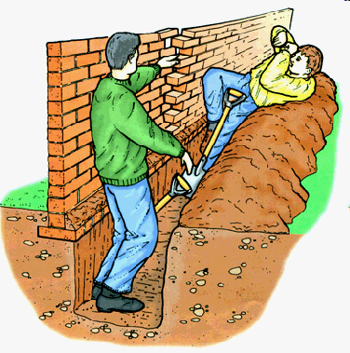

1. All excavations deeper than 1.25meters MUST be shored or battered.
2. Excavations deeper than 2 meters MUST have a guard rail or barrier
3. Vehicles working too close to the side of the trench or rubble piled on the sides may cause collapse
4. Vehicles tipping into the excavation must use stop blocks

CRANE SAFETY

Very Simply:-

The weight of the load must be carefully estimated

The crane must always work on a hard, level base

The load must be properly fixed and secured

NEVER, NEVER be carried with a load

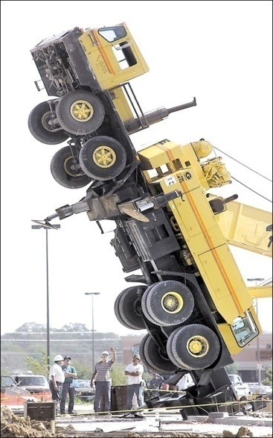

ELECTRICITY

Good practice with electricityon site:-

* Treat electricity with respect
* Check constantly that cables are not damaged or worn
* Keep trailing cables off the ground and away from water
* Never overload or use makeshift plugs and fuse



PPE on-site

Most construction sites require at least:

Hard hat

Safety Boots

Hi-viz jacket

Safety Glasses

Wear them always for

BASIC SAFETY PHILOSOPHY FOR SUCCESS

A NEW SAFETY CULTURE

All accidents are preventable.

No job is worth getting hurt for.

Every job will be done safely.

Incidents can be managed.

Safety is everyone’s responsibility.

Continuous improvement.

Safety as a “way of life” for 24 hours/day

All individuals have the responsibility and accountability to identify eliminate or manage risks associated with their workplace

Legal obligations will be the minimum requirements fro our health & safety standards

Individual will be trained and equipped to have the skills and facilities to ensure an accident free workplace



**Construction Site Safety**

**No job is so important that it cannot be done safely**

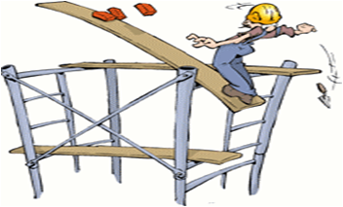

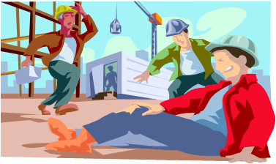

**UNDER NO CIRCUMSTANCES ARE PERSONS WORKING ON THIS SITE TO PUT THEMSELVES IN DANGER**